ỦY BAN NHÂN DÂN QUẬN HẢI CHÂU  TRƯỜNG TIỂU HỌC HOÀNG VĂN THỤ | BÀI ÔN TẬP HỌC KỲ 2 – BÀI 1  Năm học: 2020 – 2021  Môn học: ANH VĂN
Họ và tên: _______________________
Lớp : 3 / _____

- Circle the odd one out.
- A. pet B. parrot C. rabbit D. goldfish
- A. car B. plane C. toy D. kite
- A. rainy B. cloudy C. mother D. sunny
- A. reading B. skating C. cycling D. park
- Read and circle.
- _________ you have any pets? – Yes, I do.
- Does B. Do C. Are
- What toys do you like? – I like _________.
- dogs B. trucks C. cats
- How many parrots do you have? – I have _________.
- parrots B. rabbits C. two
- I have a ball and two _________.
- cars B. dogs C. cats
- Mai is _________ a book.
- cooking B. reading C. watching
- Read and complete.
Hi. My name is Nam. I have a lot of pets. This is my cat. It is on the bed. And that is my dog. It is there, under the table. I aslo have two parrots and a rabbit. They are all in the garden.
- Nam has a lot of __________.
- He has a cat, a dog, a __________ and two parrots.
- The cat is __________ the bed.
- The __________ is under the table.
- Read and match.
A | B | Answers
- What are you doing? | - It’s sunny. | 1 -
- What’s Hoa doing? | - I’m reading. | 2 -
- Where are Nam and Quan? | - She’s playing the piano. | 3 -
- What’s the weather like today? | - They’re in the park. | 4 -

- Read and write.
 | 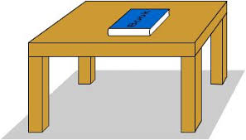
- I like __________. | - The book is __________ the table.
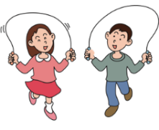

- They are __________. | - It is __________ today.

- Put the words in correct order.
- is/ There/ a/ living room/ .

- you/ have/ Do/ a/ robot/ ?

- is/ watching/ Linda/TV/.

4. many / cats / How / you / do / have / ?

