ỦY BAN NHÂN DÂN QUẬN HẢI CHÂU  TRƯỜNG TIỂU HỌC HOÀNG VĂN THỤ | BÀI ÔN TẬP HỌC KỲ 1-BÀI 6  Năm học: 2019 – 2020  Môn học: ANH VĂN
Họ và tên: _______________________
Lớp : 4 / _____

I. Look at the pictures. Look at the letters. Write the words
Example:
 | e r a s e r | e  s  a  e  r  r
1. | _ _ _ _ _ _ | r  e  a  a  c  m
2. | _ _ _ _ _ _ | e  r  l  e  t  t
3.  4. | _ _ _ _ _ _ | e  l  p  r  p  u
 | _ _ _ _ | o  k  o  b
II. Look and read. Put a tick (v) or a cross (x) in the box

Example:
 | He’s an old man. |  |  | They’re young girls.

1. | She’s a young girl. |  | 2. | He’s an old man.

3. 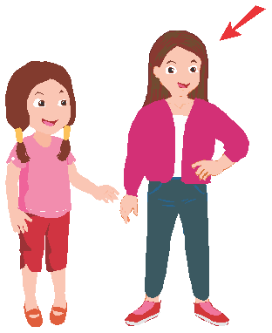 | She’s a tall girl. |  | 4. | The man is thin.

III. Read and circle “True” or “False”

Hello, my name is Tom. I’m from Greenwood. I’m eight years old. I like pets very much. There are five pets in my house. This is my dog. His name’s Lucky. He’s friendly. Dogs are my favorite pets. Rabbits are my mother’s favorite pets. These are her three rabbits. They’re cute. My sister likes cats. This is my sister’s cat. I like cats too, they’re soft.

Example:
Dogs are Tom’s favorite pets. | True | False

1. Lucky is friendly. | True | False
2. Tom’s mother has four rabbits. | True | False
3. Tom’s sister likes cats. | True | False
4. There are seven pets in his house. | True | False

IV. Look and write the words to make meaningful dialogues.
Example:
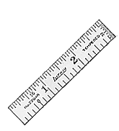 | Alfie: What’s this?  Tom: It’s a ruler.
1. | Mai: Is it a board?  Tom: No, it isn’t. It’s a …………………………………………….
2. | Mother: Remember your …………………………….……………!  Nick: Yes, Mom!
3. 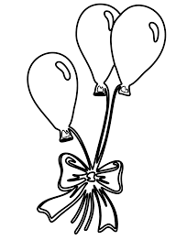 | Teacher: Look ! Lucy.  Lucy: There are three……………………………………………
4. | Nam: What’s your favorite ……………………?  Vinh: I like…………….

